TITLE:
Evaluation of India’s National Clean Air Program performance and potential health benefits
AUTHORS:
Raj M. Lal^{1,2*}, Ajay S. Nagpure¹
AFFILIATIONS:
¹World Emission Network, Princeton, NJ., 08544, USA and New Delhi, India
²Sunscreen Energy, Los Altos, CA., 94022, USA

*Corresponding Author: rajlal@worldemissionnet.com

ABSTRACT:
India, which experiences some of the highest levels of ambient air pollution and associated premature mortality worldwide, launched the National Clean Air Program (NCAP) to reduce ambient PM_{2.5} and PM₁₀ concentrations by 20-30% across 131 cities between 2017 and 2024, with a subsequent 40% target announced over an additional two-year period. We present the first comprehensive evaluation of NCAP using high-resolution satellite-based PM_{2.5} and PM₁₀ concentration fields together with surface measurements and apply the latest Global Burden of Disease (GBD) dose-response functions to estimate avoided premature mortality under the proposed reduction scenarios. Satellite-derived data show limited attainment of NCAP goals: 44 cities met the 20% PM_{2.5} target and one met the PM₁₀ target; six cities achieved the 30% PM_{2.5} target and one met the 40% target. Average improvements were 12% (8.2 µg m⁻³) for PM_{2.5} and 4.9% (5.7 µg m-3) for PM₁₀. Monitoring data indicates similarly modest progress: 7 of 29 cities met the 20% PM_{2.5} target and 43 of 96 met the PM₁₀ target. Achieving a 40% PM_{2.5} reduction across NCAP cities would avert ~36,000 annual premature mortalities. Overall, despite modest progress in some NCAP cities, stronger interventions are necessary to achieve widespread air quality and health benefits nationwide.
KEYWORDS:
National Clean Air Program, PM_{2.5}, Human Health, Air Quality, Environmental Policy
SYNOPSIS:
We utilize satellite and surface monitoring data to evaluate India’s ambitious air quality improvement targets outlined as part of the National Clean Air Program and find few cities have met the proposed targets.

INTRODUCTION:
India is widely recognized for its poor air quality, frequently reporting some of the highest levels of air pollution globally^{1,2}. Exposure to air pollution, namely fine particulate matter (PM_{2.5}), is additionally one of the leading causes of premature mortality nationwide, contributing to an estimated 2.2 million premature mortalities each year (1.2 million from ambient exposures and one million from household exposures)^{3,4}. To improve air quality, several policies targeting emission reductions have been introduced and implemented with varying degrees of success. Specifically targeting ambient PM_{2.5} and coarse particulate matter (PM₁₀) concentrations, the National Clean Air Program (NCAP) launched in 2019 with an initial target of reducing those pollutant concentration levels by 20-30% across 131 cities over a 7-year period (2017-2024)^{5–7}. Despite limited evidence that the initial targets had been achieved across the cities, an updated 40% concentration reduction target for PM₁₀ was announced over an additional 2-year period.
Prior NCAP studies have focused on emission and monitoring summaries in each of the study cities^{5,7}, assessing transboundary emission impacts to PM_{2.5} levels in the cities⁸, modeling meteorological influences to PM_{2.5} changes⁹, city-specific assessments^{10,11}, and evaluation of progress during the implementation period^{6,12}. These studies, which have addressed various aspects of NCAP, have found that there has been progress on certain critical components for the scheme, including increased institutional monitoring and inventory development capital, identified and outlined city-specific emission reduction strategies, and implemented interventions for specific sources (e.g., mobile source). However, local-scale analysis of monitoring data has not found the outlined PM_{2.5} or PM₁₀ reductions, and in many cases PM_{2.5} and PM₁₀ concentrations have increased since 2017, suggesting NCAP has room for continued policy implementation and interventions.
Here, we first utilize high-resolution, satellite-derived PM_{2.5} and PM₁₀ concentration fields and surface monitoring data between 2017 and 2024 to evaluate NCAP’s performance. We then leverage the satellite-derived PM_{2.5} fields in conjunction with the latest dose response curves from the Global Burden of Disease (GBD) to estimate the PM_{2.5}-attributed premature mortality burden in NCAP cities. Next, we evaluate the health benefits of NCAP’s various levels of PM_{2.5} concentration improvement relative to the nationwide mortality burden. Last, we build off prior work to characterize emission sector contributions to the premature mortality budget across NCAP cities.
MATERIALS AND METHODS:
Evaluating the National Clean Air Program (NCAP)’s performance
To evaluate progress toward NCAP targets, we analyzed annually-averaged satellite-derived surface PM_{2.5} (0.01°x0.01°) and PM₁₀ (0.1°x0.1°) concentration fields from the GBD⁴ and LongPMInd¹³, respectively, together with PM_{2.5} and PM₁₀ observations from the Central Pollution Control Board (CPCB) monitors. Satellite-derived concentrations were produced by fusing aerosol optical depth (AOD), chemical transport modeling outputs, and in-situ observations (Fig. 1). City-average satellite concentrations were calculated by averaging grid cells within defined urban boundaries. Monitoring-based comparisons were limited to cities with observations available in both 2017 and 2024.
Health impact assessment
Premature mortality attributable to ambient PM_{2.5} exposure in 2017 was estimated for each NCAP city using satellite-derived PM_{2.5} concentrations, gridded population data, and the latest GBD MR-BRT exposure–response functions. Health benefits of achieving NCAP’s proposed PM_{2.5} reduction targets (20%, 30%, and 40%) were estimated by applying uniform reductions to 2017 concentrations while holding population and baseline disease rates constant to isolate air quality effects. Detailed methods on the observation and health modeling are provided in the Supporting Information.
Fig. 1: The location of the 131 National Clean Air Program (NCAP) cities overlaying satellite-derived ambient PM_{2.5} concentrations in 2017.
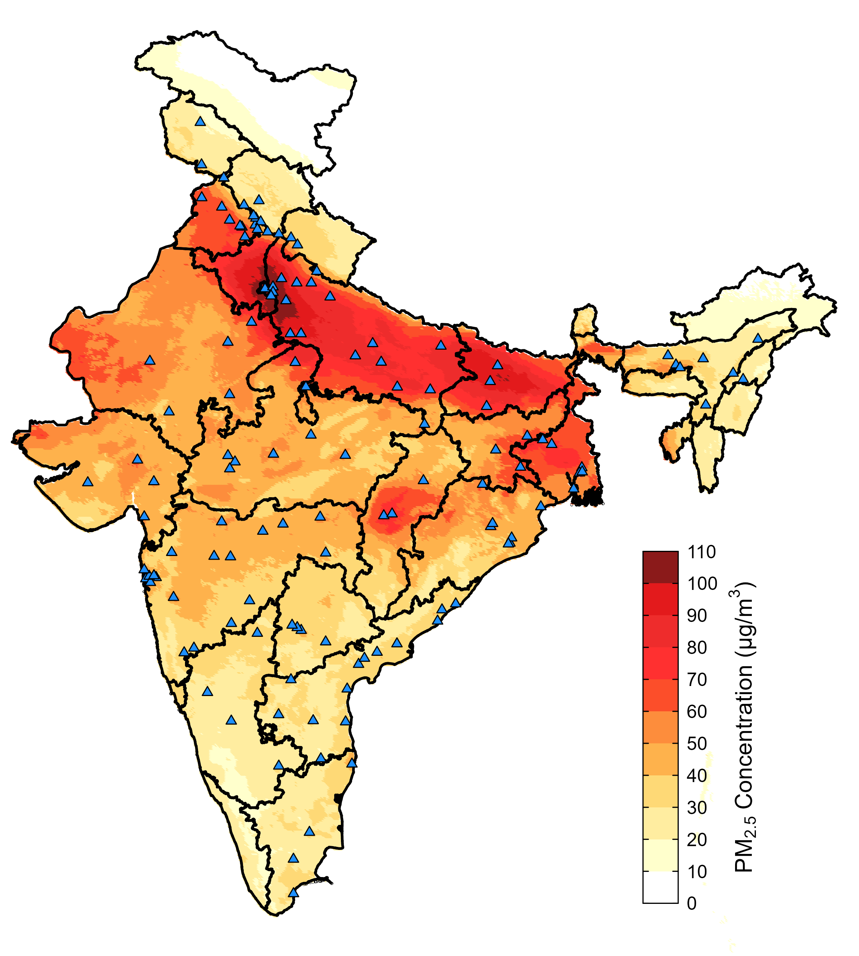
RESULTS:
Based on satellite-derived data, 44 of the 131 NCAP cities met the least stringent PM_{2.5} reduction target, while only one city met the corresponding PM₁₀ target. Across all cities, average concentration improvements were 12% (Interquartile Range; IQR: 4.3-23) [8.2 µg m⁻³ (IQR: 1.8-12.1)] for PM_{2.5} and 4.9% (IQR: 1.1-9.1) [5.6 µg m⁻³ (IQR: 1.5-8.6)] for PM₁₀ (Table 1 and Fig. 2; see SI Tables 1 and 2 for all 131 cities’ data). Further, only six cities met the 30% reduction target for PM_{2.5}, while one city achieved the 40% reduction target according to the satellite-derived data. The smaller apparent reduction in PM₁₀ relative to PM_{2.5} reflects the use of independent satellite-derived products with different spatial resolutions, retrieval approaches, and temporal coverage, rather than a physically inconsistent response of PM fractions. We found that seven of the 29 cities where PM_{2.5} monitoring data was available in 2017 and 2024 achieved the 20% reduction target, five cities met the 30% reduction target, and three met the 40% reduction goal, with an average improvement of 1.3% (IQR: -18-16) [4.3 µg m⁻³ (IQR: -6-7.5)]. For PM₁₀, 43 of the 96 cities where monitoring data was available in both years met the 20% reduction target, 28 cities met the 30% reduction target, and 15 met the 40% reduction goal, with an average improvement of 14% (IQR: 3.2-32) [27 µg m⁻³ (IQR: 3.0-43)].
Table 1: Summary of PM_{2.5} and PM₁₀ concentration changes between 2017 and 2024 in the 131 National Clean Air Program (NCAP) cities from satellite-derived and monitoring data and comparison of observations with National Ambient Air Quality Standards (NAAQS) and World Health Organization (WHO) guidelines. The negative percentage and concentration changes represent a PM improvement. City-specific data is available in SI Tables 1 and 2.
 | Satellite Observations |  | Monitor Observations
 | PM_{2.5} | PM₁₀ | PM_{2.5} | PM₁₀
Average concentration change [% (min to max); µg m⁻³ (min to max)] | -12% (37 to -45);  -8.2 µg m⁻³ (16 to -39) | -4.9% (18 to -25);  -5.7 µg m⁻³ (22 to -37) | -1.3% (43 to -73);  -4.3 µg m⁻³ (19 to -90) | -14% (48 to -79);  -27 µg m⁻³ (37 to -192)
Number of cities achieving 20% reduction target | 44 (out of 131) | 1 (out of 131) | 7 (out of 29) | 43 (out of 96)
Number of cities achieving 30% reduction target | 6 (out of 131) | 0 (out of 131) | 5 (out of 29) | 28 (out of 96)
Number of cities achieving 40% reduction target | 1 (out of 131) | 0 (out of 131) | 3 (out of 29) | 15 (out of 96)
Number of cities where concentration improved | 111 (out of 131) | 104 (out of 131) | 12 (out of 29) | 68 (out of 96)
Number of cities achieving NAAQS in 2017 | 37 (out of 131) | 4 (out of 131) | 16 (out of 37) | 3 (out of 123)
Number of cities achieving NAAQS in 2024 | 50 (out of 131) | 8 (out of 131) | 38 (out of 102) | 11 (out of 103)
Number of cities achieving WHO guideline in 2017 | 0 (out of 131) | 0 (out of 131) | 0 (out of 37) | 0 (out of 123)
Number of cities achieving WHO guideline in 2024 | 0 (out of 131) | 0 (out of 131) | 0 (out of 102) | 0 (out of 103)

Fig. 2: Distribution and spatial maps of PM_{2.5} and PM₁₀ concentration differences between 2017 and 2024 in the National Clean Air Program (NCAP) cities from monitoring and satellite-derived observations. Negative values indicate a PM concentration improvement. Spatial maps of annual satellite-derived and monitoring observations are available in SI Fig. 1.
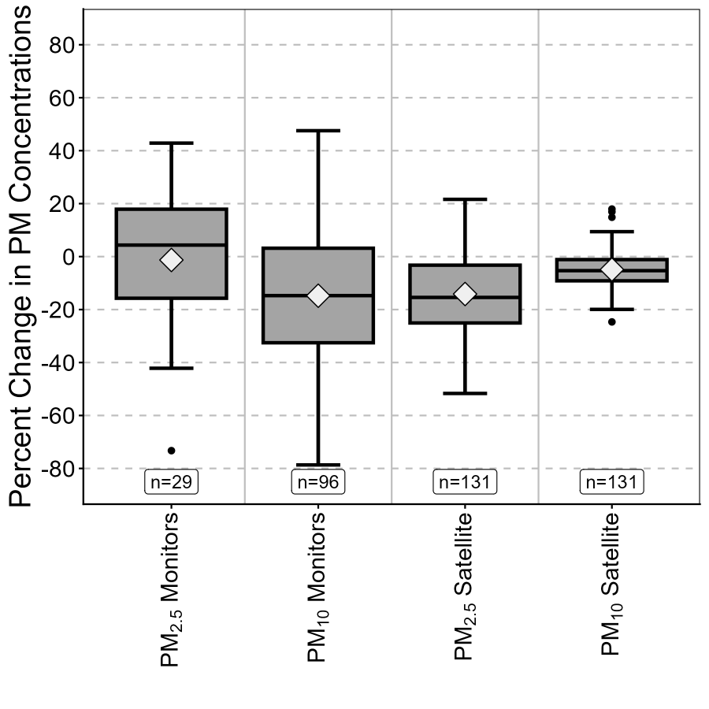

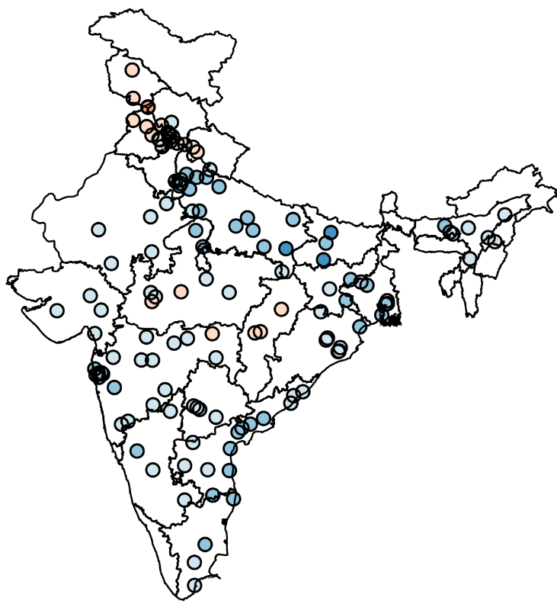
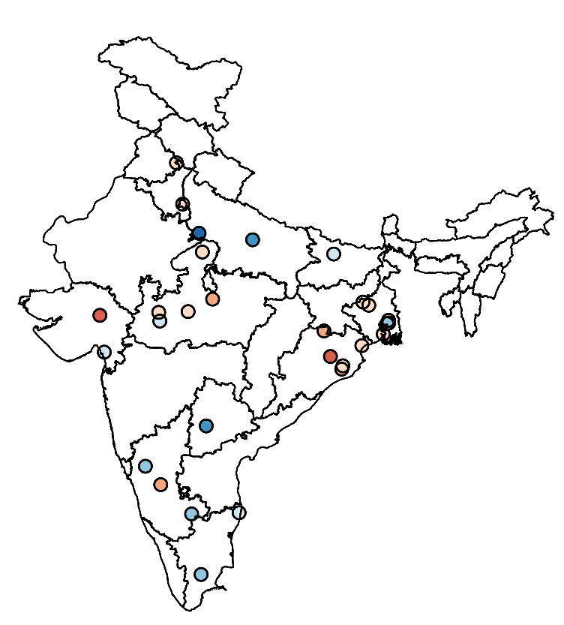
PM_{2.5} Satellite
(n=131 cities)
PM_{2.5} Monitor
(n=29 cities)

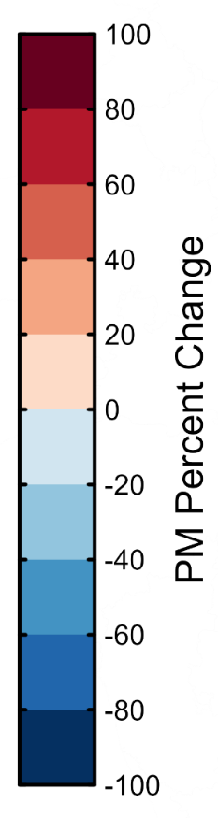

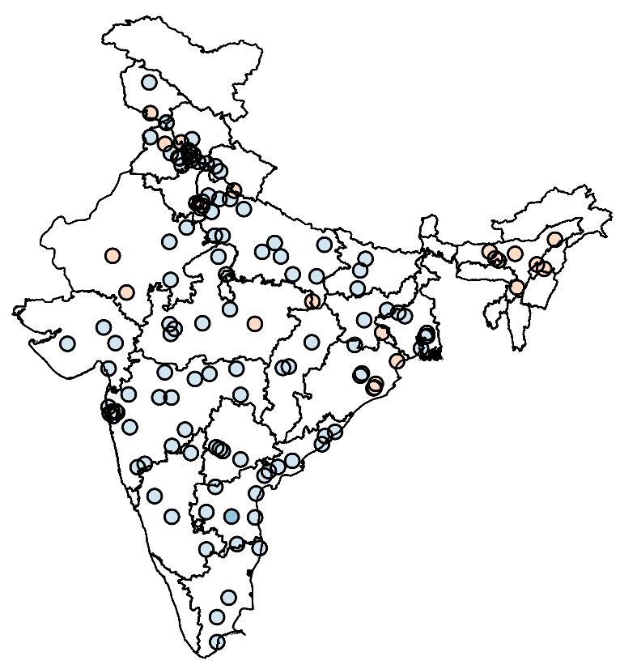
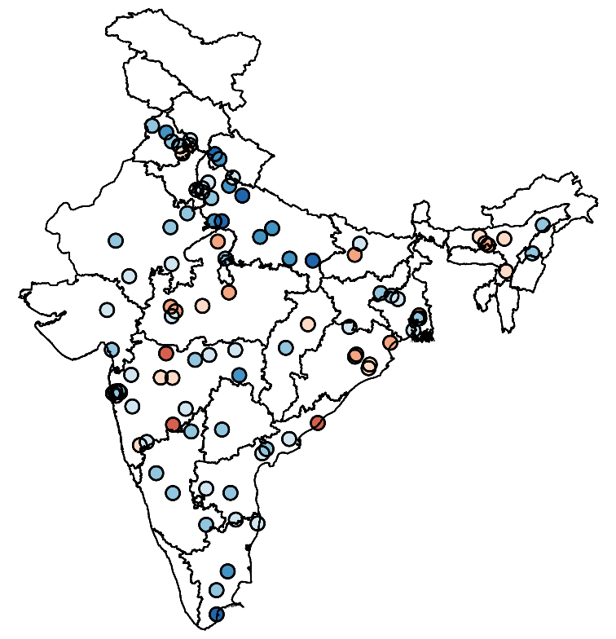
PM₁₀ Satellite
(n=131 cities)
PM₁₀ Monitor
(n=96 cities)

Satellite-derived data showed PM_{2.5} and PM₁₀ improvements across most cities nationwide (Table 1, Fig. 2, and SI Fig. 1), with the only clear regional trend of slightly higher PM₁₀ concentrations throughout central India. PM₁₀ monitoring data comparisons similarly showed nationwide improvements in most cities, with the improvements being more pronounced than their satellite-derived counterparts (Fig. 2 and SI Fig. 2). PM_{2.5} monitoring data, on the other hand, showed air quality deteriorated for the majority of NCAP cities; of the 29 cities where observational data exists in both years, only 12 of them had improved PM_{2.5} concentrations. Although most cities showed deteriorated PM_{2.5} from monitoring data, the average monitored PM_{2.5} concentration improved by 4.3 µg m⁻³ across cities (Table 1). Cities achieving NCAP targets were concentrated largely in the Indo-Gangetic Plain (IGP; SI Table 3 and SI Fig. 3), where recent shifts in residential fuel use, strengthened industrial and brick-kiln controls, and intermittently more ventilated winter conditions have likely contributed to the improvements in PM_{2.5} and PM₁₀. Outside the IGP, achievement of NCAP goals was more sporadic, with isolated successes in parts of southern and western India.
Despite generally observed air quality improvements between 2017 and 2024, the majority of NCAP cities still did not achieve the annually averaged National Ambient Air Quality Standards (NAAQS) for PM_{2.5} (40 µg m⁻³) or PM₁₀ (60 µg m⁻³) from either satellite-derived or monitoring data in both years (Table 1). We also found that none of the NCAP cities met the World Health Organization (WHO) recently revised guidelines for annually averaged PM_{2.5} (5 µg m⁻³) or PM₁₀ (15 µg m⁻³) in either study year. Nationwide population-weighted PM_{2.5} and PM₁₀ concentrations improved from 55 µg m⁻³ and 120 µg m⁻³ in 2017 to 44 µg m⁻³ and 113 µg m⁻³ in 2024, respectively (SI Fig. 4).
There were 180,000 (95% confidence interval (CI): 135,000-214,000) premature mortalities attributed to ambient PM_{2.5} exposures across the 131 NCAP cities in 2017, which was ~24% (95% CI: 16-38) of the modeled nationwide mortality burden from ambient PM_{2.5} exposures (Table 2). The highest mortality burden occurred in the most populated and polluted NCAP cities: Delhi with 40,000 mortalities (95% CI: 34,000-46,000), Mumbai with 17,000 mortalities (95% CI: 14,000-20,000), and Chennai with 10,000 mortalities (95% CI: 8,000-12,000) (see SI Table 4 for each city’s mortality burden). Of the 180,000 ambient PM_{2.5} attributed mortalities in the NCAP cities, 83,000 (95% CI: 65,000-97,000) were from IHD, 44,000 (95% CI: 38,000-49,000) from COPD, 26,000 (95% CI: 21,000-31,000) from stroke, 14,000 (95% CI: 2,000-21,000) from LRIs, 10,000 (95% CI: 6,000-13,000) from diabetes, and 3,000 (95% CI: 2,000-3,800) from TBLC. Our modeling estimated 767,000 (95% CI: 562,000-922,000) premature mortalities nationwide attributed to ambient PM_{2.5} exposures in 2017; the GBD estimated there were 888,000 (95% CI: 516,000-1,260,000) for the same year. In this analysis, we reassess the 2017 mortality burden using the most recent dose response curves, which were different than the ones used in the GBD’s 2017 analysis. In addition, the GBD found that 55,000 of their 888,000 premature mortalities were from diseases whose relative risk information were unavailable in the latest dose response curve datasets (e.g., enteric infections, maternal and neonatal disorders, encephalitis, meningitis, sudden infant death syndrome, etc.).
Table 2: Estimated premature mortalities (95% CI) attributed to ambient PM_{2.5} exposures in National Clean Air Program (NCAP) cities and nationwide under NCAP-outlined PM_{2.5} concentration improvements
 | PM_{2.5} Reduction (%)
 | 0 (Baseline Exposure) | 20 | 30 | 40
NCAP premature mortalities | 180,000  (135,000-214,000) | 165,000  (122,000-198,000) | 155,000  (114,000-187,000) | 144,000  (105,000-175,000)
Nationwide premature mortalities | 767,000  (562,000-922,000) | 691,000  (500,000-785,000) | 644,000  (463,000-785,000) | 590,000  (421,000-724,000)

15,000 (95% CI: 13,000-16,000), 25,000 (95% CI: 22,000-27,000), and 36,000 (95% CI: 30,000-39,000) premature mortalities can be avoided within NCAP cities under the respective 20%, 30%, and 40% PM_{2.5} reduction targets (Table 2), with the largest benefits again being observed in the most populated and polluted cities. Achieving the most ambitious proposed PM_{2.5} improvements within NCAP cities can mitigate ~4.6% of the nationwide ambient PM_{2.5}-attributed mortality burden. We find that emissions associated with domestic combustion (i.e., biomass cookstoves, heating, lighting, etc.; 22%), industry (19%), urban fugitive dust (15%), and energy generation (14%) are the leading contributors to the mortality budget in cities nationwide, with a clear regional trend that is consistent with the emission profiles of those areas¹⁴ (Fig. 3).
Fig. 3: Emission sector contributions to premature mortality burden in the 131 National Clean Air Program (NCAP) in 2017. The size of each pie is the logarithm of the number of mortalities within that city relative to New Delhi’s 2017 mortality burden (40,000). The summary pie shows the percent contribution of each emission sector to the cumulative mortality burden in the NCAP cities. City-specific data is available in SI Table 5.
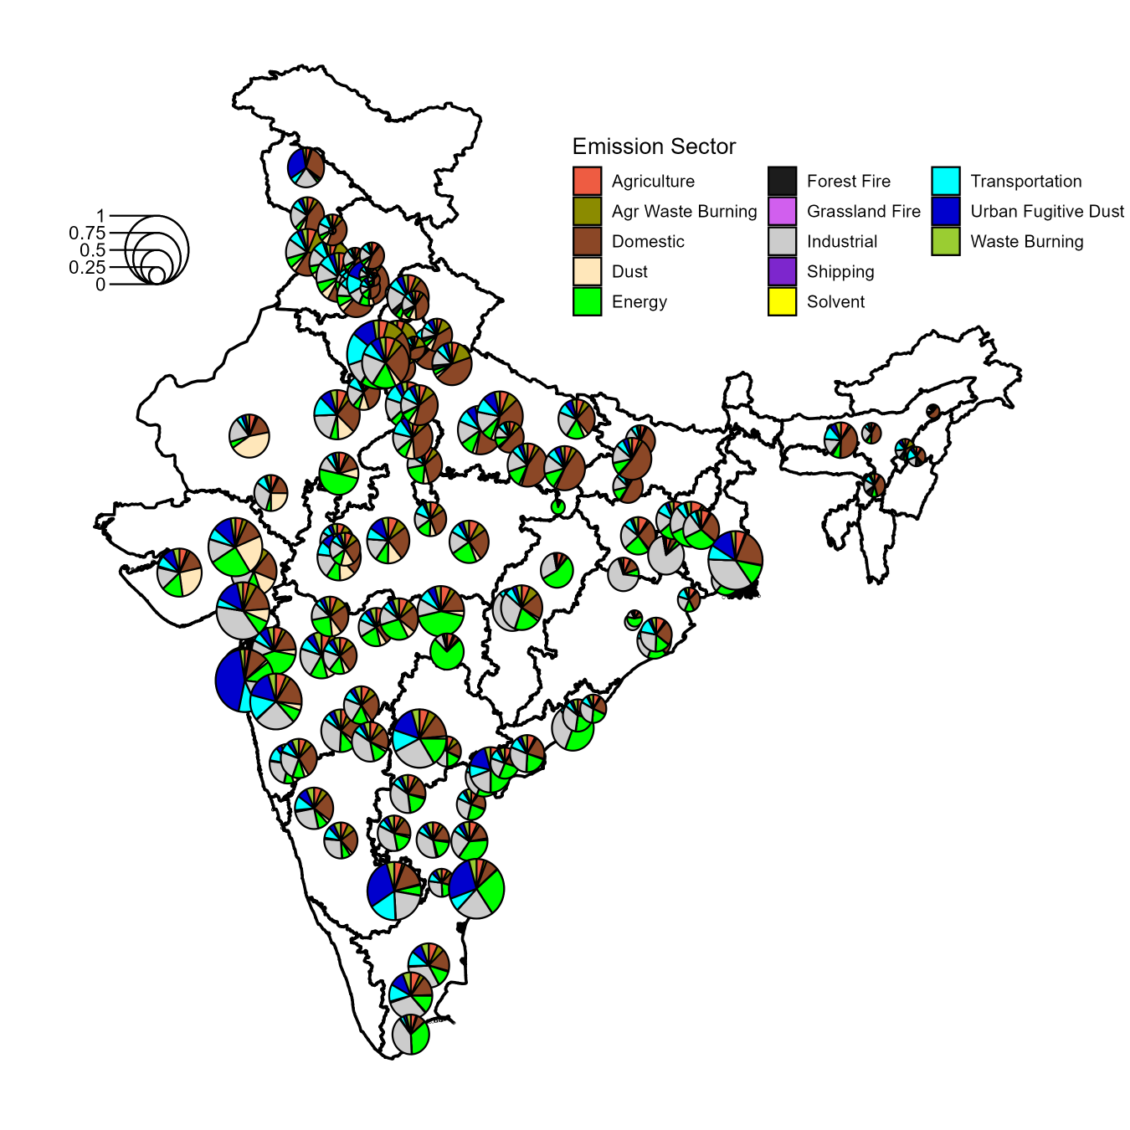

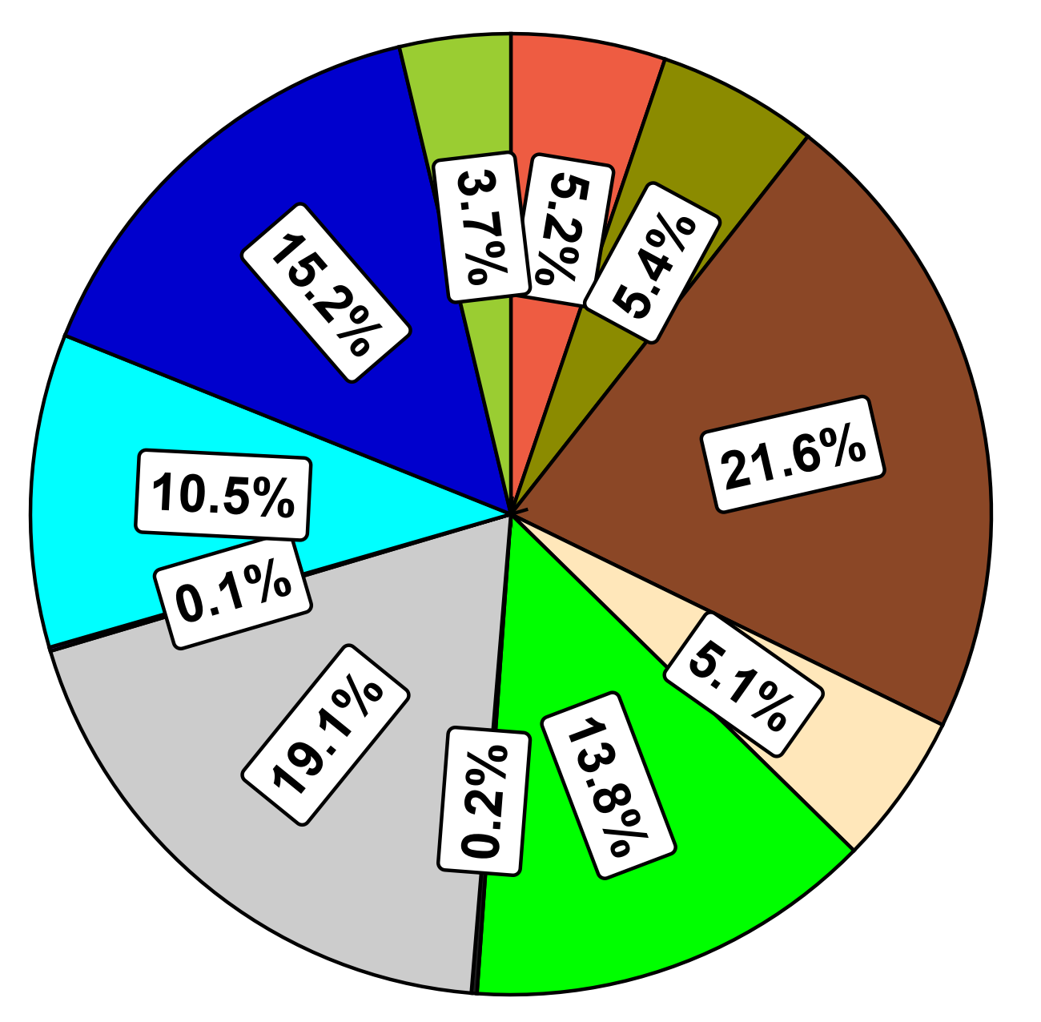

DISCUSSION:
NCAP is India’s marquee policy targeted to improve ambient air quality throughout 131 cities nationwide. It set forth an ambitious target to reduce PM_{2.5} and PM₁₀ levels by 20-30% over an initial 7-year period across 131 cities nationwide, with an added 40% reduction target over an extended 2-year period. In this work, we used high-resolution satellite-retrieved concentration fields and monitoring data to evaluate NCAP’s progress and found that while there were signs of improved air quality, the targets outlined as part of NCAP have largely been missed. We additionally found that ~23% of the nationwide ambient PM_{2.5} mortality budget comes from within NCAP cities and that achievement of the targeted air quality improvements will have large health benefits. Even so, more ambitious targets – both in terms of PM_{2.5} concentration reductions and spatial coverage – will result in even greater air quality and health benefits.
Comparison between monitoring and satellite-derived PM data highlights important differences in how NCAP-related air quality improvements should be interpreted. Satellite-derived PM_{2.5} and PM₁₀ concentrations are obtained from two independent products with distinct calibration methodologies, spatial resolutions, and temporal coverage. PM_{2.5} estimates are taken from the GBD dataset at 0.01° resolution, while PM₁₀ estimates are derived from the LongPMInd product at coarser 0.1° resolution and required extrapolation beyond 2022. As a result, satellite-derived PM₁₀ represents spatially averaged, city-wide exposure and is less sensitive to localized reductions near dominant coarse-particle sources. In contrast, CPCB monitoring data are point-based measurements that are frequently source-oriented, making them more responsive to targeted PM₁₀ interventions. Together, these differences can contribute to situations in which satellite-derived data more clearly reflect regional PM_{2.5} improvements, while monitoring data indicate larger relative reductions in PM₁₀ at specific locations, without implying a uniform response across all cities. These distinctions help explain why monitoring data shows much greater attainment of PM₁₀ reduction targets – 43, 28, and 15 cities – achieving the 20%, 30%, and 40% targets, respectively—while satellite-derived estimates indicate that only one city meets the least stringent PM₁₀ target. Taken together, satellite and monitoring data provide complementary insights into NCAP performance, capturing both population-scale exposure changes and localized source-specific improvements.
City-level NCAP expenditures further exhibit a weak and highly variable relationship with observed PM_{2.5} and PM₁₀ changes (SI Fig. 5), with higher total funds utilized not consistently corresponding to larger concentration reductions. While some high-expenditure cities show substantial PM improvements – particularly for PM₁₀ in monitoring data – many others exhibit modest or negligible changes despite comparable or greater spending. This heterogeneity suggests that the effectiveness of NCAP investments depends strongly on intervention type, baseline pollution levels, and local source characteristics, rather than expenditure alone.
Satellite-retrieved observations consistently under-predicted monitored PM_{2.5} and PM₁₀ values in 2017 and slightly over-predicted observations in 2024 (Fig. 4). Observational data from the Central Pollution Control Board (CPCB) have well-documented uncertainties related to QA/QC procedures, and sampling frequency, and site placement¹. Some CPCB monitors are source-oriented, which may bias concentrations high relative to satellite-derived products that are averaged across larger spatial domains. Satellite-derived data, in turn, are not direct measurements of aerosol mass and are subject to uncertainty depending on AOD retrieval and calibration methodology. Another target of NCAP was to increase PM_{2.5} monitoring capacity within these cities; 102 cities had PM_{2.5} observational data in 2024 compared to 37 cities in 2017 (the number of cities with PM₁₀ monitoring data decreased from 123 in 2017 to 103 in 2024).
Fig. 4: Comparison of monitoring vs. satellite-derived PM_{2.5} (left) and PM₁₀ (right) data in 2017 and 2024 with Deming regressions.
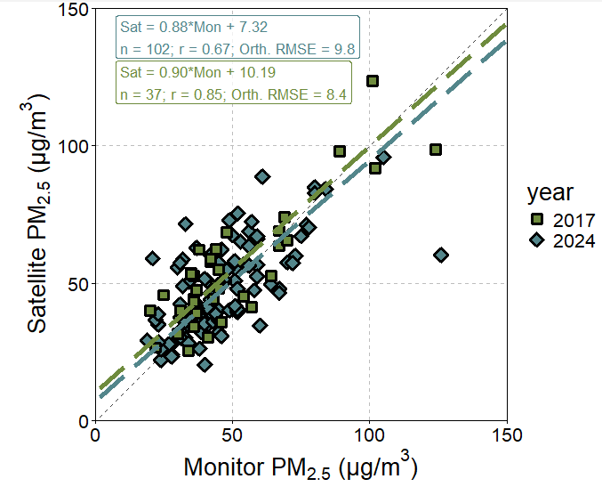
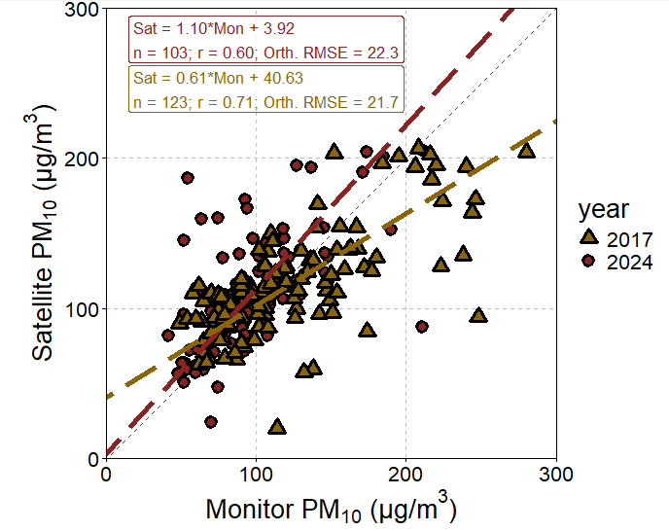

In addition to the health benefits that will occur from emission reduction strategies to reduce ambient PM_{2.5} and PM₁₀ levels, additional health benefits would occur from the expected reduced ambient O₃ concentrations stemming from anticipated O₃ precursor emission (NO_{x} and VOC) reductions. The GBD estimates that of the 1,165,000 premature mortalities associated with ambient air pollution exposure nationwide in 2021 (the most recent year that GBD estimates are available) 240,000 are from ambient O₃ exposures; the GBD additionally estimates that 1,070,000 mortalities are from household PM_{2.5} exposures. We did not explicitly model the potential O₃ benefit here because NCAP only targets PM_{2.5} and PM₁₀. Emission reduction policies targeting PM_{2.5} will have the additional co-benefit of reducing climate-forcing gas emissions and considering India is the third-highest CO₂-eq. emitting country globally, such interventions can have large global climate benefits.
There has been select, targeted policies nationwide to improve both ambient and household air quality – across the urban, rural, and regional scale – which have had a range of outcomes and successes. From various clean cooking intervention schemes (e.g., Pradhan Mantri Ujjwala Yojana (PMUY), Rajiv Gandhi Gram LPG Vidarak Yojana (RGGLV), etc.), stricter NAAQS, mandatory fuel switching at power generating units, and cleaner fuel requirements for on-road mobile sources, there has been a regulatory emphasis on emission reduction strategies. While the focus has been on reducing emissions to improve ambient air quality, a recent modeling study estimated that ~30% of annual PM_{2.5} improvements in a subset of NCAP cities from 2017 to 2022 were attributed specifically to favorable meteorological conditions that are unlikely to persist with a changing climate ⁹, suggesting that even stronger emission reduction policies will need to be implemented to achieve outlined goals. NCAP was launched as India’s first nationwide, multi-scale attempt to systematically improve ambient air quality in cities nationwide and while it has shown modest levels of progress – and in certain spots achievement of its ambitious targets – continued efforts are needed to achieve widespread air quality and health benefits nationwide.
Acknowledgements
We thank James Hite and KangKang Tong for helpful discussion throughout the course of this work and reviewing the manuscript pre-submission. There are no direct funding sources responsible for this work. RML and ASN conceptualized the study and RML performed the research and wrote the manuscript.
Supporting Information
SI Section 1 includes more details on the methods and additional figures and tables with supplemental data are provided

References
(1) Pant, P.; Lal, R. M.; Guttikunda, S. K.; Russell, A. G.; Nagpure, A. S.; Ramaswami, A.; Peltier, R. E. Monitoring Particulate Matter in India: Recent Trends and Future Outlook. Air Quality, Atmosphere & Health 2019, 12 (1), 45–58. https://doi.org/10.1007/s11869-018-0629-6.
(2) India State-Level Disease Burden Initiative Air Pollution Collaborators. Health and Economic Impact of Air Pollution in the States of India: The Global Burden of Disease Study 2019. The Lancet Planetary Health 2021, 5 (1), e25–e38. https://doi.org/10.1016/S2542-5196(20)30298-9.
(3) Murray, C. J. L. Findings from the Global Burden of Disease Study 2021. The Lancet 2024, 403 (10440), 2259–2262. https://doi.org/10.1016/S0140-6736(24)00769-4.
(4) GBD 2021 Risk Factors Collaborators. Global Burden and Strength of Evidence for 88 Risk Factors in 204 Countries and 811 Subnational Locations, 1990–2021: A Systematic Analysis for the Global Burden of Disease Study 2021. The Lancet 2024, 403 (10440), 2162–2203. https://doi.org/10.1016/S0140-6736(24)00933-4.
(5) Guttikunda, S.; Ka, N.; Ganguly, T.; Jawahar, P. Plugging the Ambient Air Monitoring Gaps in India’s National Clean Air Programme (NCAP) Airsheds. Atmospheric Environment 2023, 301, 119712. https://doi.org/10.1016/j.atmosenv.2023.119712.
(6) Guttikunda, S. K.; Dammalapati, S. K.; Pradhan, G. Assessing Air Quality during India’s National Clean Air Programme (NCAP): 2019–2023. Atmospheric Environment 2025, 343, 120974. https://doi.org/10.1016/j.atmosenv.2024.120974.
(7) Ganguly, T.; Selvaraj, K. L.; Guttikunda, S. K. National Clean Air Programme (NCAP) for Indian Cities: Review and Outlook of Clean Air Action Plans. Atmospheric Environment: X 2020, 8, 100096. https://doi.org/10.1016/j.aeaoa.2020.100096.
(8) Lal, R. M.; Nagpure, A. S.; Anand, A.; Maji, S.; Tibrewal, K.; Gupta, G.; Venkataraman, C.; Tong, K. Transboundary Emission Contribution to PM2.5 Concentrations in Indian Cities. Environmental Research Letters 2025, 20 (5), 054008. https://doi.org/10.1088/1748-9326/adc147.
(9) Xie, Y.; Zhou, M.; Hunt, K. M. R.; Mauzerall, D. L. Recent PM2.5 Air Quality Improvements in India Benefited from Meteorological Variation. Nature Sustainability 2024, 7 (8), 983–993. https://doi.org/10.1038/s41893-024-01366-y.
(10) Bera, O. P.; Venkatesh, U.; Pal, G. K.; Shastri, S.; Chakraborty, S.; Grover, A.; Joshi, H. S. Assessing the Impact of the National Clean Air Programme in Uttar Pradesh’s Non-Attainment Cities: A Prophet Model Time Series Analysis. The Lancet Regional Health – Southeast Asia 2024, 30, 100486. https://doi.org/10.1016/j.lansea.2024.100486.
(11) Dhote, L.; Sharma, P.; Dogra, S.; Arulrajan, P.; Pandey, P.; Kansal, A.; Dhiman, M.; Gautam, A. S.; Gautam, S. Quantifying the Effects of the National Clean Air Programme on Air Quality Parameters in Chandigarh: A Scientific Assessment. Aerosol Science and Engineering 2024, 8 (1), 66–76. https://doi.org/10.1007/s41810-023-00206-4.
(12) Gopikrishnan, G.; Kuttippurath, J. Impact of the National Clean Air Programme (NCAP) on the Particulate Matter Pollution and Associated Reduction in Human Mortalities in Indian Cities. Science of The Total Environment 2025, 968, 178787. https://doi.org/10.1016/j.scitotenv.2025.178787.
(13) Wang, S.; Zhang, M.; Zhao, H.; Wang, P.; Kota, S. H.; Fu, Q.; Liu, C.; Zhang, H. Reconstructing Long-Term (1980–2022) Daily Ground Particulate Matter Concentrations in India (LongPMInd). Earth System Science Data 2024, 16 (8), 3565–3577. https://doi.org/10.5194/essd-16-3565-2024.
(14) Tibrewal, K.; et al. Speciated Multipollutant Generator (SMoG) – India: An Emission Estimation and Management System for Climate and Air Quality Assessment. In revision 2026.

For Table of Contents Use Only
